Google API set up

<https://developers.google.com/gmail/api/quickstart/python>

Following this document.

Currently, we set it up in visual studio code.

Putting into terminal

pip install --upgrade google-api-python-client google-auth-httplib2 google-auth-oauthlib

BEFORE: Running this code given by the website. You NEED to set up Gmail API.

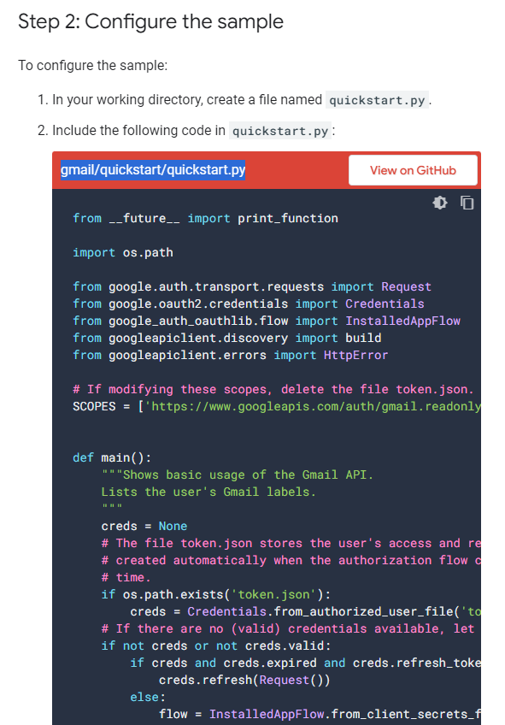

### **[Google Cloud Console](https://console.cloud.google.com/)**

[**https://console.cloud.google.com**](https://console.cloud.google.com)

Create new project

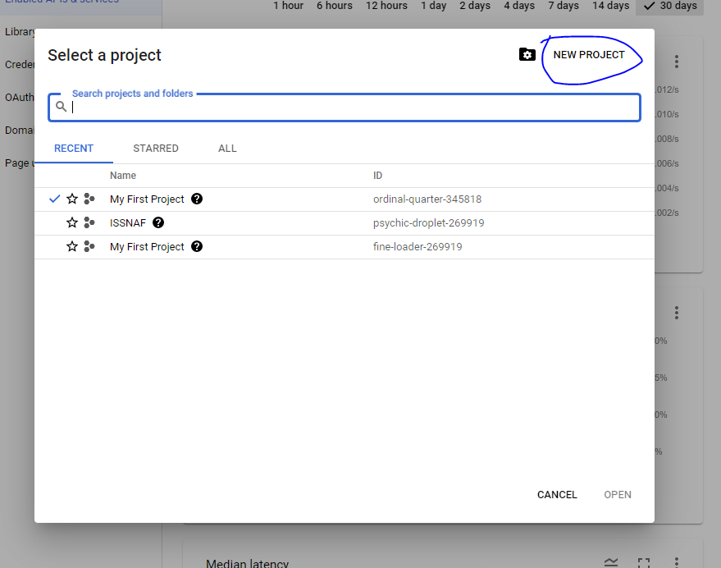

**Create the project with any name**

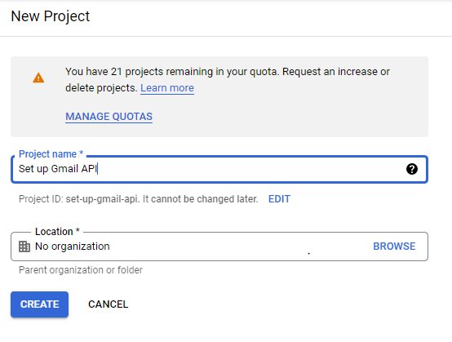

**1: go to the top left to navigate**

**2: Go to APIs & Services**

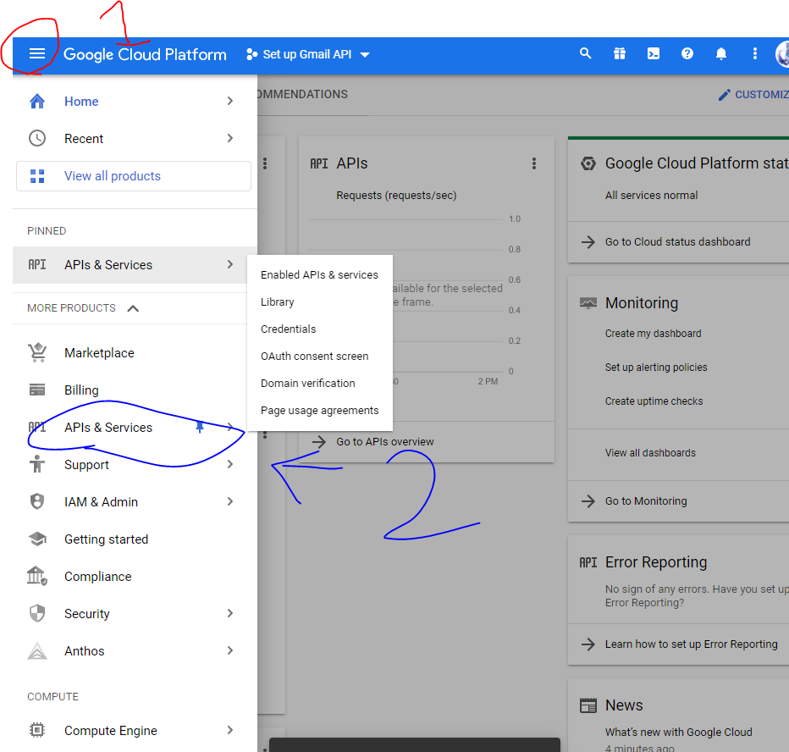

**We need to go to the library and enable Gmail API**

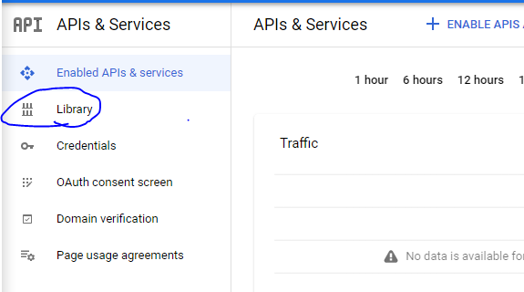

**Search in library “Gmail”**

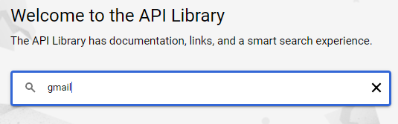

**Choose the “Gmail API” and hit enable**

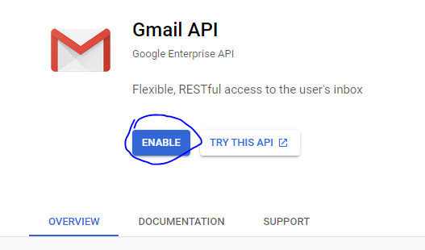

**Then go back to “API and Services”**

**Select “Credentials”**

**Select “Configure consent screen”**

**Select “External”**

**Then Create**

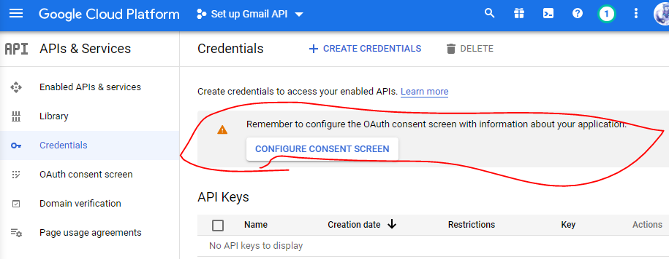

**Then you give your app name**

**User your own User support email**

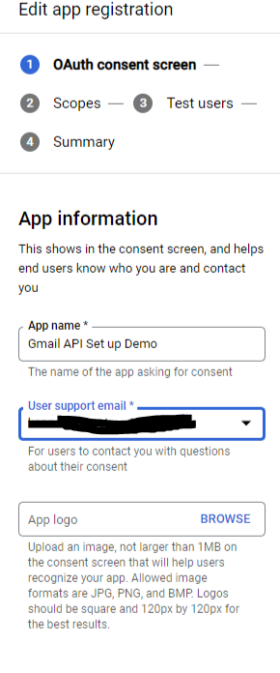

**Same thing for Developer Contact Information**

**Add your own email**

**Then save and continue**

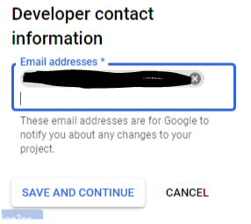

**For scopes**

**just save and continue**

**You don't have to worry about it.**

**For test user: NOTE Add your own email as the test user.**

**Add users for your teammates. For them to be allowed to use their own google account to send the email.**

**Or else another visual studio will have an error. Requires your google account login for it to send a message**

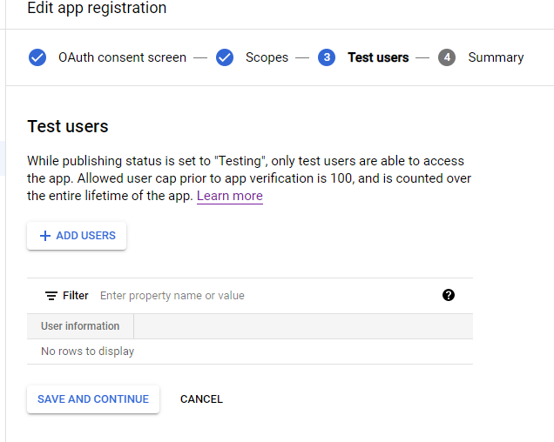

**Go to credentials**

**Then click + create credentials**

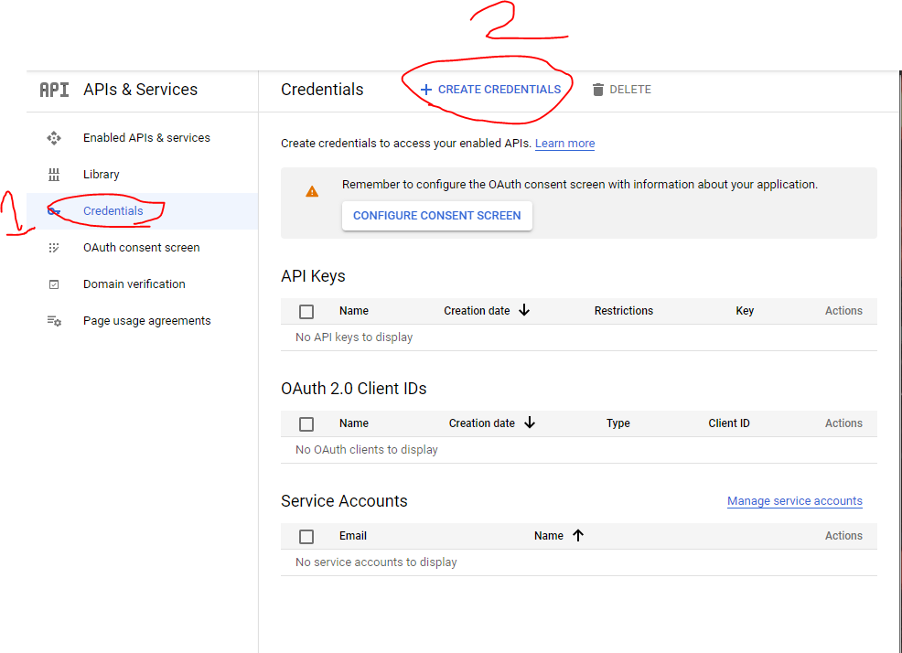

**Select “OAuth client ID”**

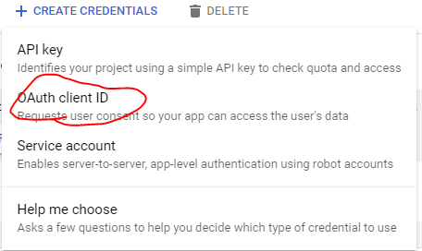

**Select Desktop app for the application type. If you are using a visual studio**

**Name it and then click create**

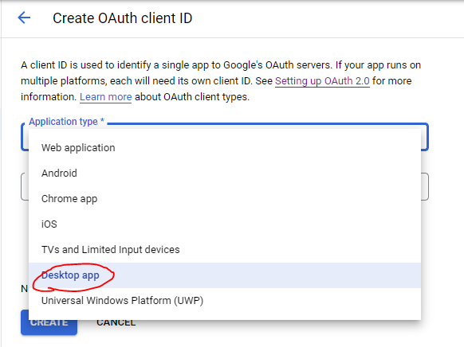

**Download JSON**

**And make sure the name is “credentials.json”**

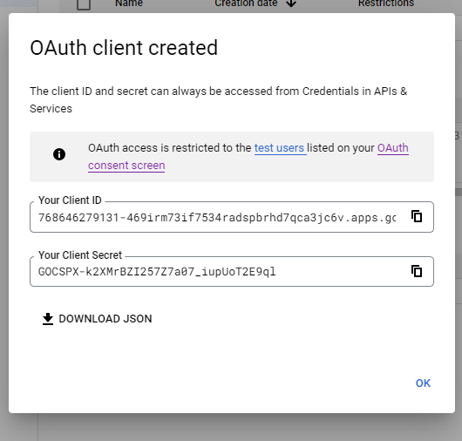

**Put the credentials.json in the directory where you’ll be coding Gmail API**

**Then grab the quickstart.py from Github.**

**Run quickstart.py in the visual studio**



**The code should bring you to a page like this**

1. **With your project name. It should display the same name you name when you create the project in the console**
2. **Click on the Google account that you have added to the test user. It has to be the same google account you added to the console.**

**Results if an account that is not in test user Unauthorized request.**

1. **After selecting your Google account.**

**Hit continue**

**And then continue again.**

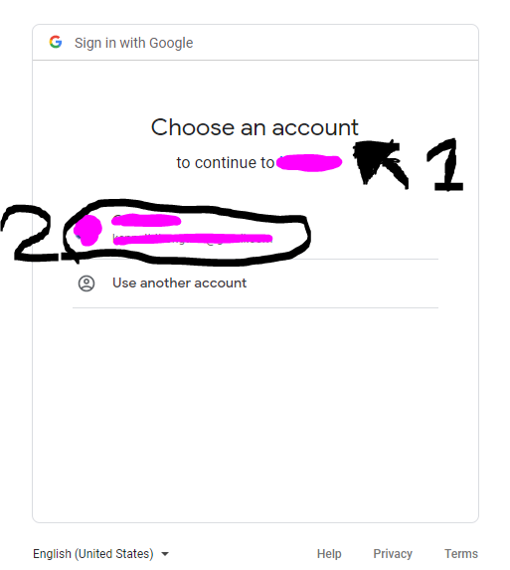

**This should show up.**

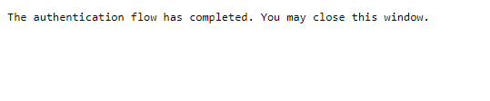

**Your visual studio should produce a token.json which acts as your ID for messaging with Gmail API.**

**If any error occurs please use** <https://developers.google.com/gmail/api/quickstart/python>

**The bottom of the page has some error fix at the bottom**

setupGoogle.py

[SetupGoogle.py Github LINK](https://github.com/CSE120-Project/Sandbox/blob/kenneth/setupGoogle.py)

This is the code provided by Google to set up the Gmail API. This code reads in your credentials.json needed from your Google Cloud Platform. When running this setupGoogle.py we will take you to a website asking you to log in to a google account and confirm it is you. After going through confirmation, the program should make you a token.json. Which acts like your ID and does expire at a certain time. I

Note:Simple trouble shooting solutions

1. Is to delete your token.json and run setupGoogle.py again.
2. Check if you have the right credentials.json in the same directory as the function

SendMessage.py

[SendMessage.py Github LINK](https://github.com/CSE120-Project/Sandbox/blob/kenneth/SendMessage.py)

The send message.py is functional code that can be called into any python. Simply type for above “from SendMessage import send_message”. Once you reference the py file function. You can simply type send_message(). This function takes in three strings.

In order is the email of the person you are sending the email to.

Second, is the subject title of the email.

Finally in the context of the email.

[Kenneth Branch ReadMe](https://github.com/CSE120-Project/Sandbox/blob/kenneth/README.md)

Set up for others.

1. You don't need to copy token.json. The token acts like an ID for that specific email and user.
2. For other users, they need your credentials.json
3. Go to<https://console.cloud.google.com/home/dashboard?project=lab5-310119> and search for 'Gmail API' and enable the API
4. Make sure that you get added as a user to the 'project' in Google Cloud Platform Console
5. In the visual studio in the terminal type the same command.

pip install --upgrade google-api-python-client google-auth-httplib2 google-auth-oauthlib

1. Run setupGoogle.py